- List the 7 main phases of the Software Testing Life Cycle (STLC) and write one line describing what happens in each phase for a Login feature like the one in Instagram or Paytm.
Ans=>
1. Requirement Analysis
The testing team studies the login feature requirements as a username/mobile number, password, OTP, validation rules.
2. Test Planning
The tester creates a testing plan by deciding scope, testing types, and tools for login testing.
3. Test Case Development
Test cases are written for scenario like valid login, invalid password, empty fields, OTP verification, and forgot password.
4. Test Environment Setup
A testing environment is the app build, devices, browsers.
5. Test Execution
Testers execute all login test cases and verify the feature works correctly.
6. Test Cycle closure
Any issues found are reported to developers.

- For a Flipkart-style Login module, create a table that lists the entry and exit criteria for each STLC phase (Planning, Monitoring, Analysis, Design, Implementation, Execution, Reporting, Closure).
Ans=> in Flipkart-style Login module
 | Entry Criteria | Exit Criteria

Planning | Login module requirements mobile/email login, OTP, password, validation are available. | Login testing scope, resources, and test plan.

Monitoring | Login testing activities started and progress is enabled. | Login testing status is reviewed and required actions are verify.

Analysis | Login requirement document available. | Test login scenarios are identified and requirement completed.

Design | Login requirement analysis is completed. | Test cases for valid login, invalid login, OTP, and forgot password done?

Implementation | Approved login test cases and application build are available. | Test environment, user accounts, devices, browsers, and test data are ready.

Execution | Login environment and test cases are ready. | Login test cases are executed, defects is completed.

Reporting | Execution results and defect details are available. | Login test report with pass/fail status and defect details is done.

Closure | All login testing activities are completed. | Final sign-off is completed and login testing is closed.

- Write a sample Test Plan section (max 1 page) for the Login module of a Zomato-like app, including objectives, scope, resources, and schedule.<br><br><em><strong>Hint:</strong> Focus on what will be tested, who will test, and the timeline for testing the Login feature.</em>
Ans=> Zomato app test plan.

INTRODUCTION
This Test Plan is designed to define the scope, objectives, resources, and schedule for testing the Login module of the Zomato application. The plan identifies the features.

1 TEST STRATEGY
1.1 Scope of Testing
1.1.1 Features to be Tested
The following login features will be tested:
- Login using Mobile Number and OTP
- Login using Email and Password
- OTP validation and verification
- Forgot Password functionality
- Validation for invalid credentials

1.1.2 Features Not to be Tested
The following features are outside the scope:
- User Registration
- Food Ordering and Checkout
- Restaurant Search and Filters
- Payment Gateway Integration

2 TEST OBJECTIVE
The objective of testing is to verify that users can successfully log into the application using supported authentication methods.

3 RESOURCE PLANNING
3.1 Human Resource
- Test Lead: Approve test plan and monitor execution progress.
- Manual Tester: Design test cases, execute tests, and report defects.
- Developer: Resolve login-related defects.
- QA Team: Perform retesting and regression testing.

3.2 System Resource
- Android and iOS test devices
- Chrome and mobile browsers
- Test user accounts
- Internet connection
- Defect tracking tool

4 SCHEDULE & ESTIMATION
Task | Responsible | Duration
Requirement Review | Test Lead | Day 1
Test Case Preparation | Tester | Day 2
Environment Setup | QA Team | Day 3
Test Execution | Tester | Day 4–5
Defect Retesting | Tester & Developer | Day 6
Test Closure Report | Test Lead | Day 7

EXIT CRITERIA
- All planned login test cases executed successfully.
- Critical and high-priority defects fixed and verified.
- Test summary report approved and testing closed.

- Design 3 test cases for the Login module of a BookMyShow-style app, covering positive, negative, and boundary scenarios. Include test steps, expected results, and actual results columns.
Ans=>
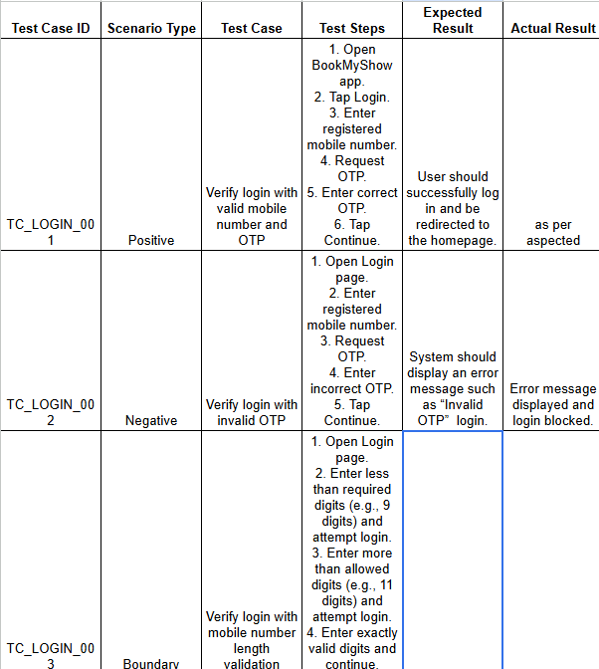

- After executing your test cases, write a short Test Summary Report for the Login module, mentioning how many tests passed, failed, and any major issues found.<br><br><em><strong>Hint:</strong> Imagine you are sending this summary to your team lead after finishing Login testing.</em>
Ans=> test summary report
Module: Login Module – BookMyShow App
Testing Type: Functional Testing
Test Execution Date: 30 June 2026
1. Test Execution Summary
Login module testing has been completed successfully based on the prepared test cases. Testing covered positive, negative, and boundary scenarios.
2. Test Result Summary
Total Test Cases Executed | 3
Passed | 2
Failed | 1
Blocked | 0
3. Major Issues Found
Defect ID | Issue Description | Severity | Status
BUG_001 | Login screen accepted mobile number with fewer than required digits and allowed OTP request. | High | Open
4. Observations
- Valid login functionality worked correctly.
- Invalid OTP validation displayed appropriate error messages.
- Boundary validation for mobile number length requires correction.

5. Recommendation
The Login module is partially ready for release. The high-priority validation issue should be fixed and retested before production deployment.

